**AWS 101 EC2 : Create Instance**

*Posted On September 5, 2019*

**How to create EC2 instance?**

**To launch the EC2 instance**  
  
1. Open the Amazon EC2 console at <https://console.aws.amazon.com/ec2/>  
  
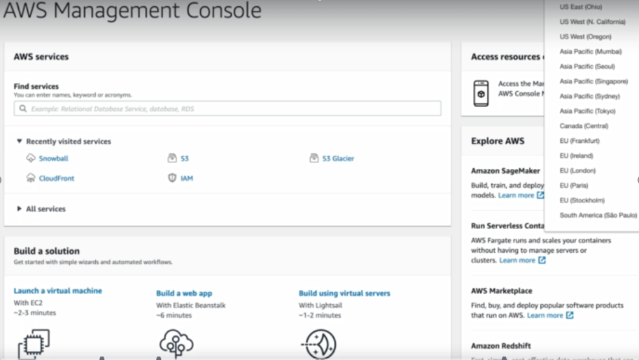  
  
2. Choose EC2 as Launch Instance  
  
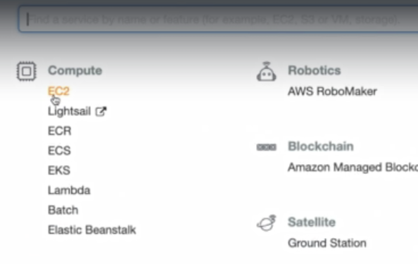  
  
3. Click on ‘Launch Instance’  
  
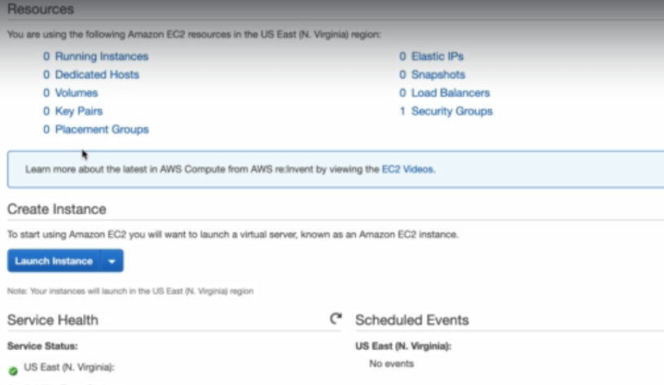  
  
4. **Choose an Amazon Machine Image (AMI)**, find an Amazon Linux AMI at the top of the list and choose **Select**.  
  
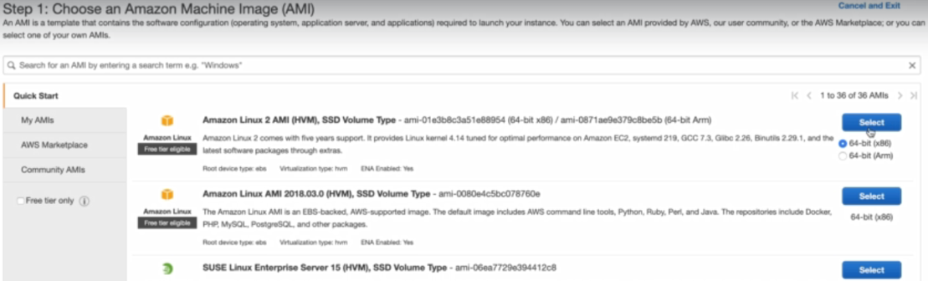  
  
5. **Choose an Instance Type**  
  
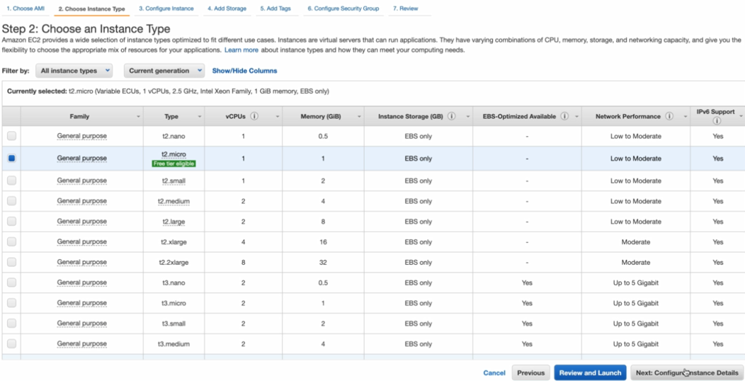  
  
6. **Configure Instance Details**,  
a. Choose **Network**,  
b. Choose the entry for your default VPC. It should look something like vpc-xxxxxxx  
c. Choose **Subnet**, and then choose a subnet in any Availability Zone  
  
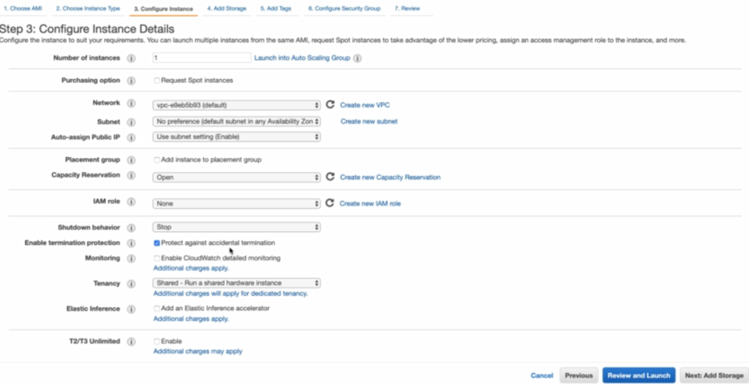  
  
7. **Add Storage**.  
  
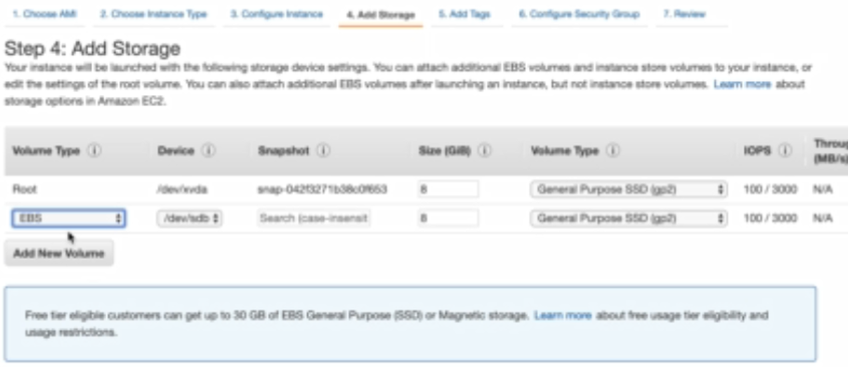  
  
8. **Add Tags**  
  
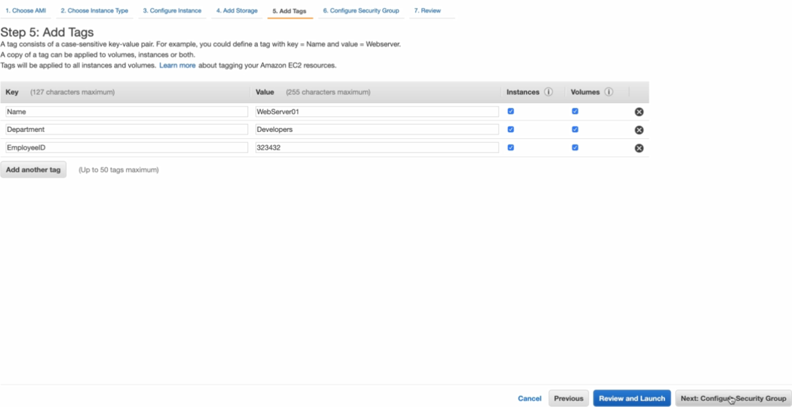  
  
9. **Configure Security Group**, **assign a security group** is set to **Create a new security group**, and verify that the inbound rule being created has the following default values.  
**Type:** SSH  
**Protocol:** TCP  
**Port Range:** 22  
**Source:** Anywhere 0.0.0.0/0  
  
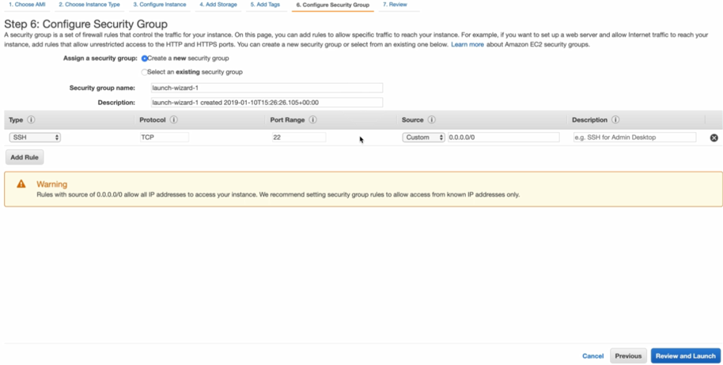  
10. Choose **Review and Launch**  
  
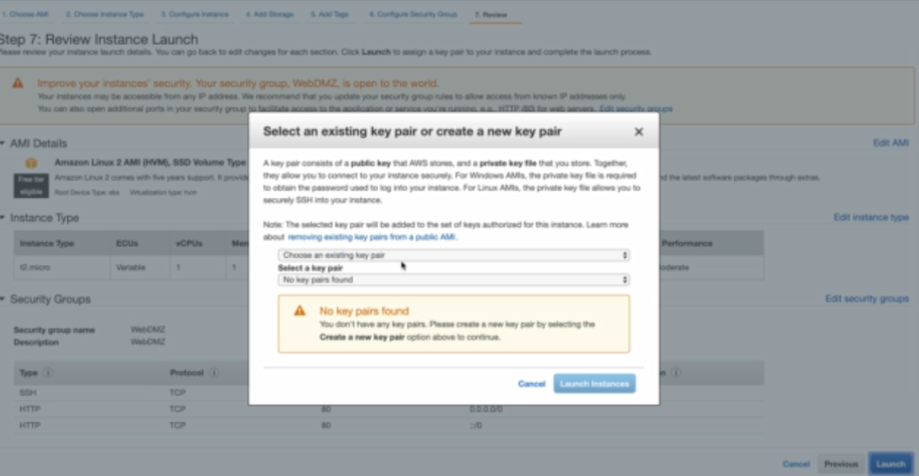  
  
11. If you created Key Pair then choose from list.  
  
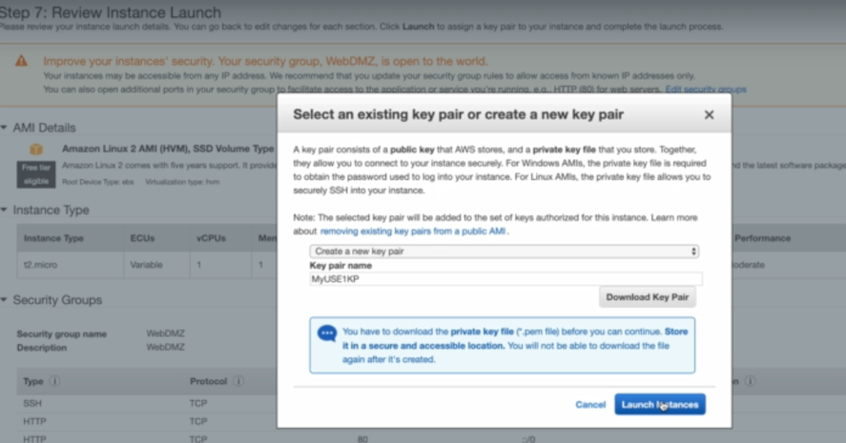  
  
12. Choose **Launch Instances** and View Details.  
  
